***Sec.10-1 (p.553)***

***For Exercises 11 through 27, perform the following steps***

1. Draw the scatter plot for the variables.
2. Compute the value of the correlation coefficient.
3. State the hypotheses.
4. Test the significance of the correlation coefficient at 𝛼 = 0.05. Using Table I or the P-value method.
5. Give a brief explanation of the type of relationship.

Assume all assumptions have been met.

|  |  |  |  |  |  |  |  |  |  |  |  |  |  |  |
| --- | --- | --- | --- | --- | --- | --- | --- | --- | --- | --- | --- | --- | --- | --- |
| 12. The average gasoline price per gallon and the cost of a barrel of oil are shown for a random selection of weeks in 2015. Is there a linear relationship between the variables?   |  |  |  |  |  |  |  | | --- | --- | --- | --- | --- | --- | --- | | **Oil ($)** | 51.91 | 60.65 | 59.56 | 52.86 | 45.12 | 44.21 | | **Gasoline ($)** | 1.97 | 1.96 | 2.06 | 2.04 | 2.00 | 1.99 | |

1. scatter plot

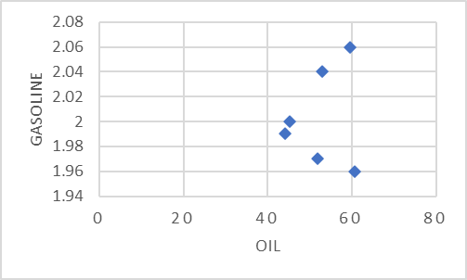

1. correlation coefficient

|  |  |  |  |  |
| --- | --- | --- | --- | --- |
| $$x$$ | $$y$$ | $$xy$$ | $$x^{2}$$ | $$y^{2}$$ |
| 51.91 | 1.97 | 102.263 | 2694.648 | 3.881 |
| 60.65 | 1.96 | 118.874 | 3678.423 | 3.842 |
| 59.56 | 2.06 | 122.694 | 3547.394 | 4.244 |
| 52.86 | 2.04 | 107.834 | 2794.180 | 4.162 |
| 45.12 | 2.00 | 90.240 | 2035.814 | 4.000 |
| 44.21 | 1.99 | 87.978 | 1954.524 | 3.960 |
| $$∑x=314.31$$ | $$∑y=12.02$$ | $$∑xy=629.883$$ | $$∑x^{2}=16704.983$$ | $$∑y^{2}=24.089$$ |

$$r=\frac{n∑xy-∑x∑y}{\sqrt{\left[n∑x^{2}-{\left(∑x\right)}^{2}\right]\left[n∑y^{2}-{\left(∑y\right)}^{2}\right]}} \\ =\frac{6⋅629.883-314.31⋅12.02}{\sqrt{\left(6⋅16704.983-{314.31}^{2}\right)\left(6⋅24.089-{12.02}^{2}\right)}} \\ =0.147$$

1. hypothesis
$$H_{0}:ρ=0 v.s. H_{1}:ρ≠0$$

2. test with $α=0.05$

$$d.f.=n-2=4⇒R=\left\{\left|r\right|≥0.811\right\}$$

$0.147≱0.811⇒$ 不拒絕 $H_{0}$

There is not enough evidence to conclude that there is a significant linear relationship between the average gasoline price per gallon and the cost of a barrel of oil at 𝛼 = 0.05.

我們沒有足夠的證據表明在 𝛼 = 0.05 時，每加侖汽油價格與每桶石油的成本之間存在顯著的線性關係。

1. explaination of the type of relationship

The linear correlation coefficient suggests a weak positive linear relationship between the average gasoline price per gallon and the cost of a barrel of oil.

線性相關係數表明每加侖平均汽油價格與每桶石油成本之間呈現弱的正相關。

|  |  |  |  |  |  |  |  |  |  |  |  |  |
| --- | --- | --- | --- | --- | --- | --- | --- | --- | --- | --- | --- | --- |
| 16. An economics student wishes to see if there is a relationship between the amount of state debt per capita and the amount of tax per capita at the state level. Based on the following data, can she or he conclude that per capita state debt and per capita state taxes are related? Both amounts are in dollars and represent five randomly selected states.   |  |  |  |  |  |  | | --- | --- | --- | --- | --- | --- | | **Per capita debt $x$** | 1924 | 907 | 1445 | 1608 | 661 | | **Per capita tax $y$** | 1685 | 1838 | 1734 | 1842 | 1317 | |

amount of state debt per capita 人均州債務數額;

amount of tax per capita at the state level 州級人均稅收數額;

1. scatter plot

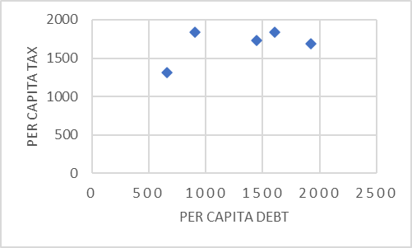

1. correlation coefficient

|  |  |  |  |  |
| --- | --- | --- | --- | --- |
| $$x$$ | $$y$$ | $$xy$$ | $$x^{2}$$ | $$y^{2}$$ |
| 1924 | 1685 | 3241940 | 3701776 | 2839225 |
| 907 | 1838 | 1667066 | 822649 | 3378244 |
| 1445 | 1734 | 2505630 | 2088025 | 3006756 |
| 1608 | 1842 | 2961936 | 2585664 | 3392964 |
| 661 | 1317 | 870537 | 436921 | 1734489 |
| $$∑x=6545$$ | $$∑y=8416$$ | $$∑xy=11247109$$ | $$∑x^{2}=9635035$$ | $$∑y^{2}=14351678$$ |

$$r=\frac{n∑xy-∑x∑y}{\sqrt{\left[n∑x^{2}-{\left(∑x\right)}^{2}\right]\left[n∑y^{2}-{\left(∑y\right)}^{2}\right]}}=0.518$$

1. hypothesis
$$H_{0}:ρ=0 v.s. H_{1}:ρ≠0$$

2. test with $α=0.05$

$$d.f.=n-2=3⇒R=\left\{\left|r\right|≥0.878\right\}$$

$0.518≱0.878⇒$ 不拒絕 $H_{0}$

There is not enough evidence to conclude that there is a significant linear relationship between the amount of state debt per capita and the amount of tax per capita at the state level at 𝛼 = 0.05.

我們沒有足夠的證據表明在 𝛼 = 0.05 時，人均州債務數額與州級人均稅收數額之間存在顯著的線性關係。

1. explaination of the type of relationship

The linear correlation coefficient suggests a positive linear relationship between the amount of state debt per capita and the amount of tax per capita at the state level.

線性相關係數表明人均州債務數額與州級人均稅收額之間存在正相關。

|  |  |  |  |  |  |  |  |  |  |  |  |  |  |  |  |  |
| --- | --- | --- | --- | --- | --- | --- | --- | --- | --- | --- | --- | --- | --- | --- | --- | --- |
| 20. Here are the number of grams of water and the number of grams of carbohydrates for a random selection of raw foods. Is there a linear relationship between the variables?   |  |  |  |  |  |  |  |  | | --- | --- | --- | --- | --- | --- | --- | --- | | **Water** | 83.93 | 80.76 | 87.66 | 85.20 | 72.85 | 84.61 | 83.81 | | **Carbs** | 15.25 | 16.55 | 11.10 | 13.01 | 24.27 | 14.13 | 15.11 | |

carbohydrates 碳水化合物; raw foods 生食;

1. scatter plot

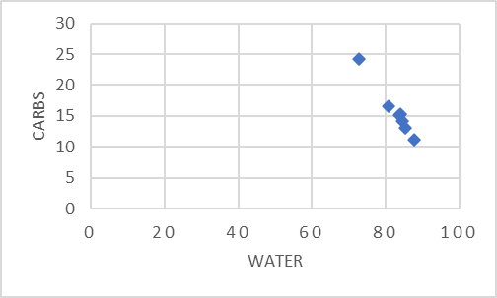

1. correlation coefficient

|  |  |  |  |  |
| --- | --- | --- | --- | --- |
| $$x$$ | $$y$$ | $$xy$$ | $$x^{2}$$ | $$y^{2}$$ |
| 83.93 | 15.25 | 1279.933 | 7044.245 | 232.563 |
| 80.76 | 16.55 | 1336.578 | 6522.178 | 273.903 |
| 87.66 | 11.1 | 973.026 | 7684.276 | 123.210 |
| 85.2 | 13.01 | 1108.452 | 7259.040 | 169.260 |
| 72.85 | 24.27 | 1768.070 | 5307.123 | 589.033 |
| 84.61 | 14.13 | 1195.539 | 7158.852 | 199.657 |
| 83.81 | 15.11 | 1266.369 | 7024.116 | 228.312 |
|  |  |  |  |  |

1. hypothesis
2. test with

拒絕

There is enough evidence to conclude that there is a significant linear relationship between the number of grams of water and the number of grams of carbohydrates at 𝛼 = 0.05.

我們有足夠的證據表明在 𝛼 = 0.05 時，水的克數與碳水化合物的克數之間存在顯著的線性關係。

1. explaination of the type of relationship

The linear correlation coefficient suggests a strong negative linear relationship between the number of grams of water and the number of grams of carbohydrates.

線性相關係數表明水的克數和碳水化合物的克數之間存在很強的負相關。

|  |  |  |  |  |  |  |  |  |  |  |  |  |  |  |  |  |  |  |  |  |  |  |
| --- | --- | --- | --- | --- | --- | --- | --- | --- | --- | --- | --- | --- | --- | --- | --- | --- | --- | --- | --- | --- | --- | --- |
| 26. An architect wants to determine the relationship between the heights (in feet) of buildings and the number of stories in the buildings. The data for a sample of 10 buildings in Chicago are shown. Explain the relationship (if any).   |  |  |  |  |  |  |  |  |  |  |  | | --- | --- | --- | --- | --- | --- | --- | --- | --- | --- | --- | | **Stories $x$** | 64 | 68 | 50 | 48 | 32 | 46 | 58 | 45 | 49 | 40 | | **Height $y$** | 995 | 844 | 732 | 679 | 648 | 635 | 610 | 600 | 583 | 573 | |

architect 建築師; feet 呎; number of stories in the buildings 建築物樓層數;

1. scatter plot

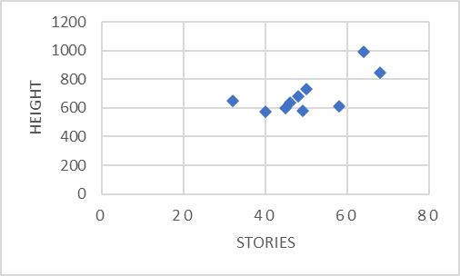

1. correlation coefficient

|  |  |  |  |  |
| --- | --- | --- | --- | --- |
| $$x$$ | $$y$$ | $$xy$$ | $$x^{2}$$ | $$y^{2}$$ |
| 64 | 995 | 63680 | 4096 | 990025 |
| 68 | 844 | 57392 | 4624 | 712336 |
| 50 | 732 | 36600 | 2500 | 535824 |
| 48 | 679 | 32592 | 2304 | 461041 |
| 32 | 648 | 20736 | 1024 | 419904 |
| 46 | 635 | 29210 | 2116 | 403225 |
| 58 | 610 | 35380 | 3364 | 372100 |
| 45 | 600 | 27000 | 2025 | 360000 |
| 49 | 583 | 28567 | 2401 | 339889 |
| 40 | 573 | 22920 | 1600 | 328329 |
| $$∑x=500$$ | $$∑y=6899$$ | $$∑xy=354077$$ | $$∑x^{2}=26054$$ | $$∑y^{2}=4922673$$ |

$$r=\frac{n∑xy-∑x∑y}{\sqrt{\left[n∑x^{2}-{\left(∑x\right)}^{2}\right]\left[n∑y^{2}-{\left(∑y\right)}^{2}\right]}}=0.696$$

1. hypothesis
$$H_{0}:ρ=0 v.s. H_{1}:ρ≠0$$

2. test with $α=0.05$

$$d.f.=n-2=8⇒R=\left\{\left|r\right|≥0.632\right\}$$

$0.696>0.632⇒$ 拒絕 $H_{0}$

There is enough evidence to conclude that there is a significant linear relationship between the heights of buildings and the number of stories in the buildings at 𝛼 = 0.05.

我們有足夠的證據表明在 𝛼 = 0.05 時，建築物的高度與建築物的樓層數之間存在顯著的線性關係。

1. explaination of the type of relationship

The linear correlation coefficient suggests a positive linear relationship between the heights of buildings and the number of stories in the buildings.

線性相關係數表明建築物高度與樓層數之間呈現正相關。

***Sec. 10-2 (******p.562)***

***For Exercises 11 through 27, use the same data as for the corresponding exercises in Section 10-1.***

For each exercise, find the equation of the regression line and find the y' value for the specified x value. Remember that no regression should be done when r is not significant.

|  |  |  |  |  |  |  |  |  |  |  |  |  |  |  |  |  |  |  |
| --- | --- | --- | --- | --- | --- | --- | --- | --- | --- | --- | --- | --- | --- | --- | --- | --- | --- | --- |
| 14. Number of fires and number of acres burned are as follows:   |  |  |  |  |  |  |  |  |  | | --- | --- | --- | --- | --- | --- | --- | --- | --- | | **Fires $x$** | 72 | 69 | 58 | 47 | 84 | 62 | 57 | 45 | | **Acres $y$** | 62 | 42 | 19 | 26 | 51 | 15 | 30 | 15 |   Find 𝑦 ′ when 𝑥 = 60 fires. |

number of acres burned燒毀面積;

1. correlation coefficient

|  |  |  |  |  |
| --- | --- | --- | --- | --- |
| $$x$$ | $$y$$ | $$xy$$ | $$x^{2}$$ | $$y^{2}$$ |
| 72 | 62 | 4464 | 5184 | 3844 |
| 69 | 42 | 2898 | 4761 | 1764 |
| 58 | 19 | 1102 | 3364 | 361 |
| 47 | 26 | 1222 | 2209 | 676 |
| 84 | 51 | 4284 | 7056 | 2601 |
| 62 | 15 | 930 | 3844 | 225 |
| 57 | 30 | 1710 | 3249 | 900 |
| 45 | 15 | 675 | 2025 | 225 |
| $$∑x=494$$ | $$∑y=260$$ | $$∑xy=17285$$ | $$∑x^{2}=31692$$ | $$∑y^{2}=10596$$ |

$$r=\frac{n∑xy-∑x∑y}{\sqrt{\left[n∑x^{2}-{\left(∑x\right)}^{2}\right]\left[n∑y^{2}-{\left(∑y\right)}^{2}\right]}}=0.771$$

1. hypothesis
$$H_{0}:ρ=0 v.s. H_{1}:ρ≠0$$

2. test with $α=0.05$

$$d.f.=n-2=6⇒R=\left\{\left|r\right|≥0.707\right\}$$

$0.771>0.707⇒$ 拒絕 $H_{0}$

There is enough evidence to conclude that there is a significant linear relationship between the number of fires and the number of acres burned at 𝛼 = 0.05.

我們有足夠的證據表明在 𝛼 = 0.05 時，火災次數與燒燬面積之間存在顯著的線性關係。

1. r顯著時計算迴歸方程式並代入

$$a=\frac{∑y∑x^{2}-∑x∑xy}{n∑x^{2}-{\left(∑x\right)}^{2}}=-31.46$$

$$b=\frac{n∑xy-∑x∑y}{n∑x^{2}-{\left(\sum{x}\right)}^{2}}=1.036$$

Hence, the equation of the regression line 𝑦 ′ = 𝑎 + 𝑏𝑥 is

$$y^{'}=-31.46+1.036⋅x$$

When 𝑥 = 60, 𝑦 ′ = −31.46 + 1.036 × 60 = 30.7

|  |  |  |  |  |  |  |  |  |  |  |  |  |  |  |  |  |
| --- | --- | --- | --- | --- | --- | --- | --- | --- | --- | --- | --- | --- | --- | --- | --- | --- |
| 20. Here are the number of grams of water and the number of grams of carbohydrates for a random selection of raw foods (100 g each).   |  |  |  |  |  |  |  |  | | --- | --- | --- | --- | --- | --- | --- | --- | | **Water** | 83.93 | 80.76 | 87.66 | 85.20 | 72.85 | 84.61 | 83.81 | | **Carbs** | 15.25 | 16.55 | 11.10 | 13.01 | 24.27 | 14.13 | 15.11 |   Find 𝑦 ′ for 𝑥 = 75. |

1. correlation coefficient

|  |  |  |  |  |
| --- | --- | --- | --- | --- |
| $$x$$ | $$y$$ | $$xy$$ | $$x^{2}$$ | $$y^{2}$$ |
| 83.93 | 15.25 | 1279.933 | 7044.245 | 232.563 |
| 80.76 | 16.55 | 1336.578 | 6522.178 | 273.903 |
| 87.66 | 11.1 | 973.026 | 7684.276 | 123.210 |
| 85.2 | 13.01 | 1108.452 | 7259.040 | 169.260 |
| 72.85 | 24.27 | 1768.070 | 5307.123 | 589.033 |
| 84.61 | 14.13 | 1195.539 | 7158.852 | 199.657 |
| 83.81 | 15.11 | 1266.369 | 7024.116 | 228.312 |
|  |  |  |  |  |

1. hypothesis
2. test with

拒絕

There is enough evidence to conclude that there is a significant linear relationship between the number of grams of water and the number of grams of carbohydrates at 𝛼 = 0.05.

我們有足夠的證據表明在 𝛼 = 0.05 時，水的克數與碳水化合物的克數之間存在顯著的線性關係。

1. r顯著時計算迴歸方程式並代入

$$a=\frac{∑y∑x^{2}-∑x∑xy}{n∑x^{2}-{\left(∑x\right)}^{2}}=87.408$$

$$b=\frac{n∑xy-∑x∑y}{n∑x^{2}-{\left(\sum{x}\right)}^{2}}=-0.868$$

Hence, the equation of the regression line 𝑦 ′ = 𝑎 + 𝑏𝑥 is

$$y^{'}=87.408-0.868⋅x$$

When 𝑥 = 75, 𝑦 ′ = 87.408 − 0.868 × 75 = 22.308

***For Exercises 28 through 33, do a complete regression analysis by performing these steps.***

1. Draw a scatter plot.
2. Compute the correlation coefficient.
3. State the hypotheses.
4. Test the hypotheses at a = 0.05. Use Table I, or use the P-value method.
5. Determine the regression line equation if r is significant.
6. Plot the regression line on the scatter plot, if appropriate.
7. Summarize the results.

|  |  |  |  |  |  |  |  |  |  |  |  |  |  |  |
| --- | --- | --- | --- | --- | --- | --- | --- | --- | --- | --- | --- | --- | --- | --- |
| 28. These data were obtained for the years 2009 through 2014 and indicate the number of fireworks (in millions) used and the related injuries. Predict the number of injuries if 200 million fireworks are used during a given year.   |  |  |  |  |  |  |  | | --- | --- | --- | --- | --- | --- | --- | | **Fireworks in use $x$** | 213.9 | 205.9 | 234.1 | 207.5 | 186.4 | 225.3 | | **Related injuries $y$** | 8800 | 8600 | 9600 | 8600 | 11400 | 10500 | |

1. scatter plot

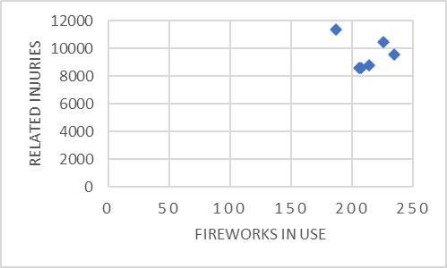

1. correlation coefficient

|  |  |  |  |  |  |
| --- | --- | --- | --- | --- | --- |
|  | $$x$$ | $$y$$ | $$xy$$ | $$x^{2}$$ | $$y^{2}$$ |
|  | 213.9 | 8800 | 1882320 | 45753.21 | 77440000 |
|  | 205.9 | 8600 | 1770740 | 42394.81 | 73960000 |
|  | 234.1 | 9600 | 2247360 | 54802.81 | 92160000 |
|  | 207.5 | 8600 | 1784500 | 43056.25 | 73960000 |
|  | 186.4 | 11400 | 2124960 | 34744.96 | 129960000 |
|  | 225.3 | 10500 | 2365650 | 50760.09 | 110250000 |
| $$∑=$$ | 1273.1 | 57500 | 12175530 | 271512.13 | 557730000 |

$$r=\frac{n∑xy-∑x∑y}{\sqrt{\left[n∑x^{2}-{\left(∑x\right)}^{2}\right]\left[n∑y^{2}-{\left(∑y\right)}^{2}\right]}}=-0.260$$

1. hypothesis
$$H_{0}:ρ=0 v.s. H_{1}:ρ≠0$$

2. test with $α=0.05$

$$d.f.=n-2=4⇒R=\left\{\left|r\right|≥0.811\right\}$$

$\left|-0.260\right|≱0.811⇒$ 不拒絕 $H_{0}$

There is not enough evidence to conclude that there is a significant linear relationship between the number of fireworks used and the related injuries at 𝛼 = 0.05.

我們沒有足夠的證據表明在 𝛼 = 0.05 時，使用的煙火數量與相關傷害之間存在顯著的線性關係。

Hence, no regression should be done.

|  |  |  |  |  |  |  |  |  |  |  |  |  |  |  |  |  |  |  |  |  |  |  |
| --- | --- | --- | --- | --- | --- | --- | --- | --- | --- | --- | --- | --- | --- | --- | --- | --- | --- | --- | --- | --- | --- | --- |
| 32. A television executive selects 10 television shows and compares the average number of viewers the show had last year with the average number of viewers this year. The data (in millions) are shown. Describe the relationship.   |  |  |  |  |  |  |  |  |  |  |  | | --- | --- | --- | --- | --- | --- | --- | --- | --- | --- | --- | | **Viewers last year $x$** | 26.6 | 17.85 | 20.3 | 16.8 | 20.8 | 16.7 | 19.1 | 18.9 | 16.0 | 15.8 | | **Viewers this year $y$** | 28.9 | 19.2 | 26.4 | 13.7 | 20.2 | 18.8 | 25.0 | 21.0 | 16.8 | 15.3 | |

television executive 電視主管;

1. scatter plot

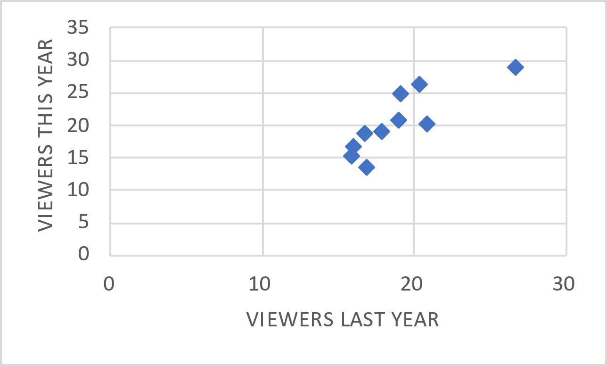

1. correlation coefficient

|  |  |  |  |  |  |
| --- | --- | --- | --- | --- | --- |
|  | $$x$$ | $$y$$ | $$xy$$ | $$x^{2}$$ | $$y^{2}$$ |
|  | 26.6 | 28.9 | 768.74 | 707.56 | 835.21 |
|  | 17.85 | 19.2 | 342.72 | 318.623 | 368.64 |
|  | 20.3 | 26.4 | 535.92 | 412.09 | 696.96 |
|  | 16.8 | 13.7 | 230.16 | 282.24 | 187.69 |
|  | 20.8 | 20.2 | 420.16 | 432.64 | 408.04 |
|  | 16.7 | 18.8 | 313.96 | 278.89 | 353.44 |
|  | 19.1 | 25 | 477.5 | 364.81 | 625 |
|  | 18.9 | 21 | 396.9 | 357.21 | 441 |
|  | 16 | 16.8 | 268.8 | 256 | 282.24 |
|  | 15.8 | 15.3 | 241.74 | 249.64 | 234.09 |
| $$∑=$$ | 188.85 | 205.3 | 3996.6 | 3659.703 | 4432.31 |

$$r=\frac{n∑xy-∑x∑y}{\sqrt{\left[n∑x^{2}-{\left(∑x\right)}^{2}\right]\left[n∑y^{2}-{\left(∑y\right)}^{2}\right]}}=0.839$$

1. hypothesis
$$H_{0}:ρ=0 v.s. H_{1}:ρ≠0$$

2. test with $α=0.05$

$$d.f.=n-2=8⇒R=\left\{\left|r\right|≥0.632\right\}$$

$0.839>0.632⇒$ 拒絕 $H_{0}$

There is enough evidence to conclude that there is a significant linear relationship between the

average number of viewers the show had last year and the average number of viewers this year at 𝛼 = 0.05.

我們有足夠的證據表明在 𝛼 = 0.05 時，去年的平均觀眾人數與今年的平均觀眾人數之間存在顯著的線性關係。

1. r顯著時計算迴歸方程式

$$a=\frac{∑y∑x^{2}-∑x∑xy}{n∑x^{2}-{\left(∑x\right)}^{2}}=-3.668$$

$$b=\frac{n∑xy-∑x∑y}{n∑x^{2}-{\left(\sum{x}\right)}^{2}}=1.281$$

Hence, the equation of the regression line 𝑦 ′ = 𝑎 + 𝑏𝑥 is

$$y^{'}=-3.668+1.281⋅x$$

1. 在散佈圖上畫出迴歸線

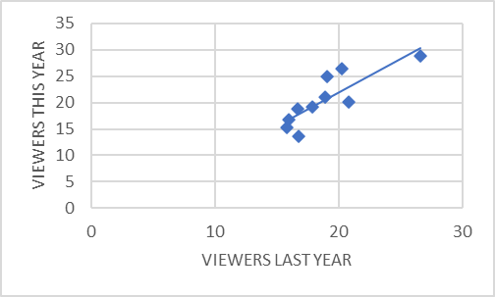

1. summarize

The linear correlation coefficient suggests a positive linear relationship between the average number of viewers the show had last year and the average number of viewers this year.

線性相關係數表明該節目去年的平均觀眾人數與今年的平均觀眾人數之間存在正相關。

***Sec. 10-3 (******p.581)***

***For Exercises 8 through 13, find the coefficients of determination and nondetermination and explain the meaning of each.***

|  |
| --- |
| 8. $r=0.62$ |

**coefficients of determination**

$$r^{2}={0.62}^{2}=0.3844$$

38.44% of the variation of y is due to the variation of x.

38.44% 的 y 變異是由 x 的變異所引起的

**coefficients of nondetermination**

$$1-r^{2}=0.6156$$

61.56% is due to chance.

61.56%的 y 變異是隨機的

|  |
| --- |
| 12. $r=0.12$ |

**coefficients of determination**

$$r^{2}={0.12}^{2}=0.0144$$

1.44% of the variation of y is due to the variation of x.

1.44% 的 y 變異是由 x 的變異所引起的

**coefficients of nondetermination**

$$1-r^{2}=0.9856$$

98.56% is due to chance.

98.56%的 y 變異是隨機的

|  |  |  |  |  |  |  |  |  |  |  |  |  |  |  |  |  |  |  |
| --- | --- | --- | --- | --- | --- | --- | --- | --- | --- | --- | --- | --- | --- | --- | --- | --- | --- | --- |
| 16. Compute the standard error of the estimate for Exercise 14 in Section 10-1. The regression line equation was found in Exercise 14 in Section 10-2.   |  |  |  |  |  |  |  |  |  | | --- | --- | --- | --- | --- | --- | --- | --- | --- | | **Fires $x$** | 72 | 69 | 58 | 47 | 84 | 62 | 57 | 45 | | **Acres $y$** | 62 | 42 | 19 | 26 | 51 | 15 | 30 | 15 | |

|  |
| --- |
| 20. For the data in Exercises 14 in Sections 10-1 and 10-2 and 16 in Section 10-3, find the 95% prediction interval when x = 60 years. |

|  |  |  |  |  |
| --- | --- | --- | --- | --- |
|  |  |  |  |  |
| 72 | 62 | 4464 | 5184 | 3844 |
| 69 | 42 | 2898 | 4761 | 1764 |
| 58 | 19 | 1102 | 3364 | 361 |
| 47 | 26 | 1222 | 2209 | 676 |
| 84 | 51 | 4284 | 7056 | 2601 |
| 62 | 15 | 930 | 3844 | 225 |
| 57 | 30 | 1710 | 3249 | 900 |
| 45 | 15 | 675 | 2025 | 225 |
|  |  |  |  |  |

|  |  |
| --- | --- |
|  |  |

Hence the 95% prediction interval when 𝑥 = 60 is (−0.559, 31.259).

|  |  |  |  |  |  |  |  |  |  |  |  |  |
| --- | --- | --- | --- | --- | --- | --- | --- | --- | --- | --- | --- | --- |
| 18. Compute the standard error of the estimate for Exercise 16 in Section 10-1. The regression line equation was found in Exercise 16 in Section 10-2.   |  |  |  |  |  |  | | --- | --- | --- | --- | --- | --- | | **Per capita debt $x$** | 1924 | 907 | 1445 | 1608 | 661 | | **Per capita tax $y$** | 1685 | 1838 | 1734 | 1842 | 1317 | |

Since $r$ is not significant, the standard error should not be calculated. (10-1 #16)

|  |
| --- |
| 22. For the data in Exercises 16 in Sections 10-1 and 10-2 and 18 in Section 10-3, find the 98% prediction interval when x = 47 years. |

Since $r$ is not significant, the prediction interval should not be calculated. (10-1 #16)